Agency Admin Training Guide 2013

The mission of the Safety Net Alliance of Clermont County is to increase the efficiency and effectiveness of emergency services provided to Clermont County low income families through collaboration. There are dozens of safety net providers in Clermont County, so the keys to achieving our mission and building leverage are collaboration and communication.
http://www.ccsafetynet.org/

June 2013

The Safety Net Alliance Website: Its Importance and Its Uses
The purpose of the Safety Net Alliance web portal is to allow members immediate access to and across agencies in the Safety Net Alliance. It is a web portal, not a web site, because of its interactive capabilities.
The Home page, below, is the central point where you can get to every page within the site. Let’s review the orange navigation panel on the top right of the image shown below.
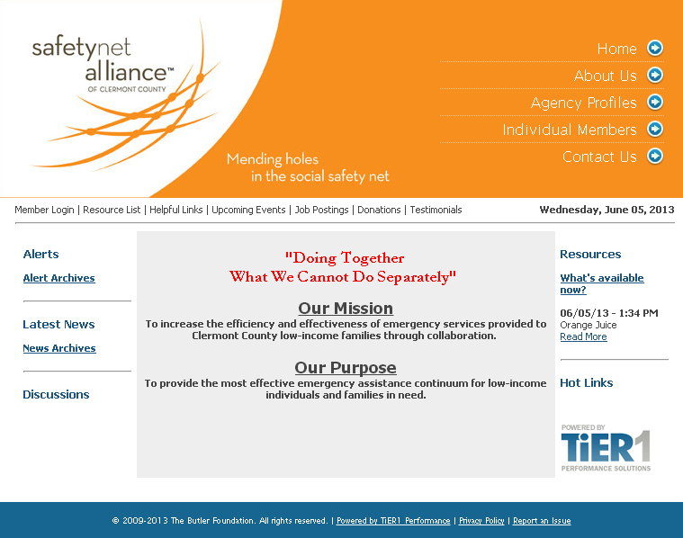
Home – alerts, news, hot links, CCSNA mission statement, links to pages within the site
About Us – information about the Safety Net Alliance
Agency Profiles – find information on all partner agencies, including contact information and provided services
Individual Members – list of all members that represent a Safety Net Alliance partner agency
Contact Us – find the email address of the Super Admin
Users can search for information about a specific agency, service, or individual member of the Safety Net Alliance by visiting sections this top panel. Users can also seek out information by referring to the Resource List for regularly updated documents. A bounty of information can be accessed without even logging into the web portal!
SNA Web Portal User Types
All individuals representing CCSNA partner agencies have the option of getting login ability to the web portal. Once the member has been added as a contact person, system access can be granted. There are three different levels of login ability: Super Administrator, Agency User, and Agency Administrator.
Super Admin – has the highest level of access to the site. These members should be contacted by Agency Admins and Agency Users with questions, ideas, or concerns.
A Super Admin can do the following:
- update information for all agency users
- update web page content for the site, including uploading documents and adding job postings
- create new alert type categories
- create new service type categories
Current Super Admin Users
Brandon Little brandon@lbcohio.com
Ruchi Bawa ruchibawa@hotmail.com
Lindsey Ein Lindsey@interparish.org

An Agency User can do the following:
- Publish alerts and news
- Post to the Discussion Board
- Edit any alerts, news or discussions he or she personally published
- Manage personal email options (opt in or out of any or all alerts)
- Edit personal profile, including contact information

An Agency Admin can do everything an Agency User can, plus:
- Edit the his/her agency profile, including hours and services
- Add or delete contacts within his/her agency, and grant system access
- Edit information for any contact within his/her agency, including login name and password
- Edit news, alerts, discussions posted by anyone in his/her agency

The Role of the Agency Admin
Expectations
- Keep individual agency’s general information, services, and contact information up to date
- Attend Safety Net Alliance meetings or assign a responsibly Agency User to attend as a representative
- Post relevant alerts and news to keep other agencies informed
- Keep all Agency Users or contacts current; delete any contact that is no longer employed with that agency

Responsibilities
- Adding, removing, updating any information under the tabs for the Agency Admin’s login page, especially:
My Organization – If something needs to be updated since you have filled out the form, simply go in and replace the existing information with the updated information. This tab is shown in the image below.
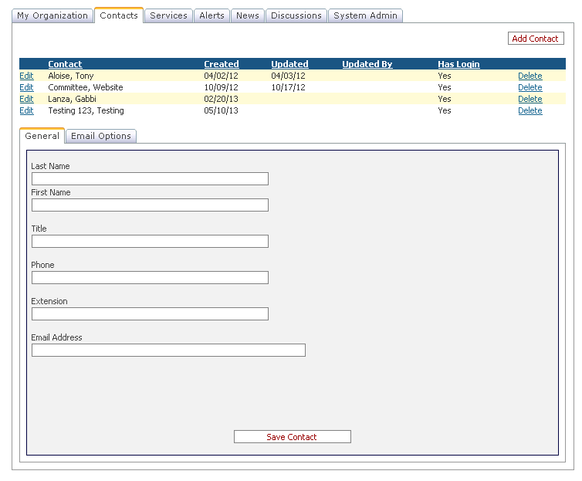
Contacts – contact information must be edited individually by clicking “edit” next to each contact’s name. Deleting a contact will remove them completely from the portal.
To add a contact to your organization, go to the “Contacts” tab, pictured right, and select “Add Contact.” Enter the person’s name and email – job title and phone number are optional.
Once the contact is added, go to the “System Admin” tab, pictured below, and then click the “Add System Access” button. Select the contact from the drop-down menu. Assign a Login Name and a Password, choose if he or she is an Agency User or an Agency Admin, and finally select Approved.
Note: Passwords must be a minimum of 7 characters. Also, there can be more than one Admin per agency. This, actually, might be ideal for smaller organizations who may not be able to use the site often.
Email Compatibilities
There are several types of alerts one can post on the site. Everyone with a user login and password has the option to opt-in or opt-out of receiving emails when certain types of alerts are posted. By default, everyone who has a username and password will receive emails when any type of alert is posted. However, anyone is able to opt out of a type if he or she so chooses.
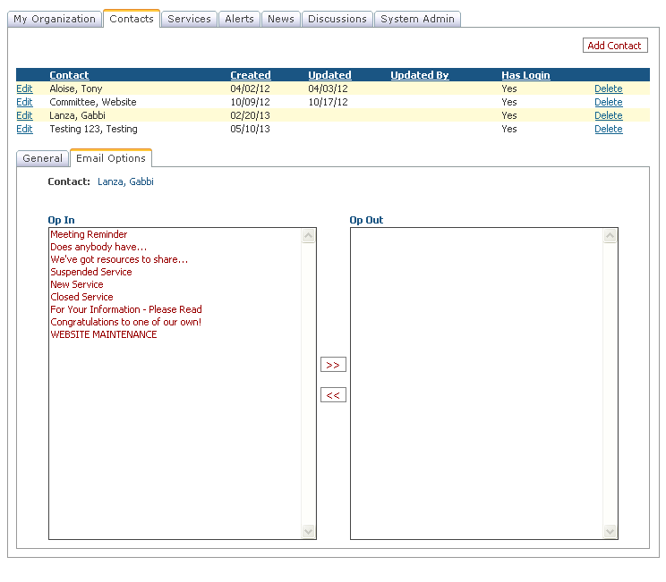
The Agency Admin has the ability to control his or her own email settings, as well as other Users in his/her agency. Users can control their own email options. It is preferred that everyone within the site be opted in for all types of alerts. Click on the alert type and then click the arrow pointing to the Opt In box. Do this for each alert type. Then go to the General tab and click Update Contact. Do this for each contact listed in your agency, including yourself. The user’s page shown on the left will receive all emailed alerts.

Who Should Be An Agency Admin?
Someone in his or her agency who has some type of tenure, someone who is dependable in regards to time management and organization, possibly someone who has basic technology skills (does not need to be proficient in all things computer related).

Alerts & News: Their Importance and the Difference between the Two
These two functions are important ways for agencies to stay informed. These two areas are part of the main reasons for creating this web portal. For more information, please refer to the Alerts Training document.
Alerts – These are like bulletins of information that need to be sent right away. They are generally only a few sentences with very time sensitive information.
News – This section is an area for articles or more lengthy information. This can be a paragraph consisting of various dates or lists of contacts and their information. One can post an alert with a small summary about something of interest and then elaborate on that item in the News section.

